

HITEC University, Taxila
BS Cyber Security 3rd Semester
Fall 2025

Lab Report # 10

Subject: Artificial Intelligence

Submitted By: Abdul Majid (24-CYS-021)
Muhammad Usama(24-CYS-013)

Section: B

Submitted To: Mr Mubahsir Iqbal

BS Cyber Security Program Department of Computer Science HITEC UNIVERSITY, TAXILA

Task no 01:
a) What is the mean age of individuals in the heart_disease dataset?
b) How many people have heart disease, and how many do not?
c) What is the maximum and minimum cholesterol level?
d) How many individuals have a BMI over 30?
e) List the number of individuals who have high blood pressure and also have heart disease.
f) Create a histogram of BMI distribution. What is the most common BMI range?
g) Create a bar chart comparing the number of heart disease cases across different exercise habits.
h) Which group has the lowest heart disease risk?
i) Create a pie chart showing the proportion of smokers vs non-smokers.
j) What percentage of the dataset are smokers?
k) Create a scatter plot of BMI vs Triglyceride Level.
l) Is there any visible trend or clustering?
m) Create a box plot for the Sleep Hours data.
n) What is the median number of sleep hours?
o) Are there any outliers?

Code:

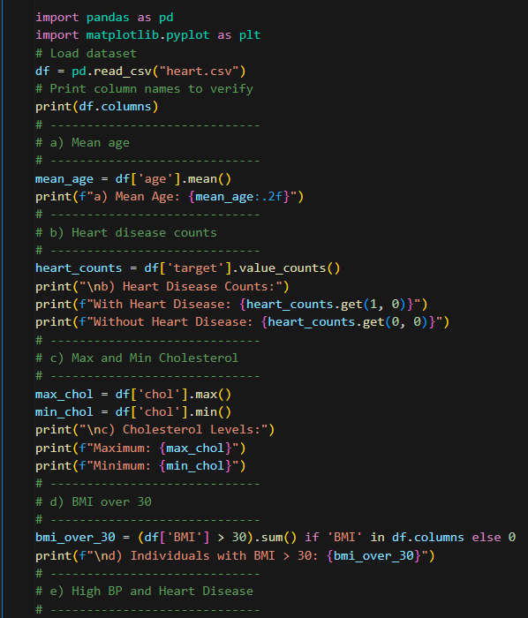
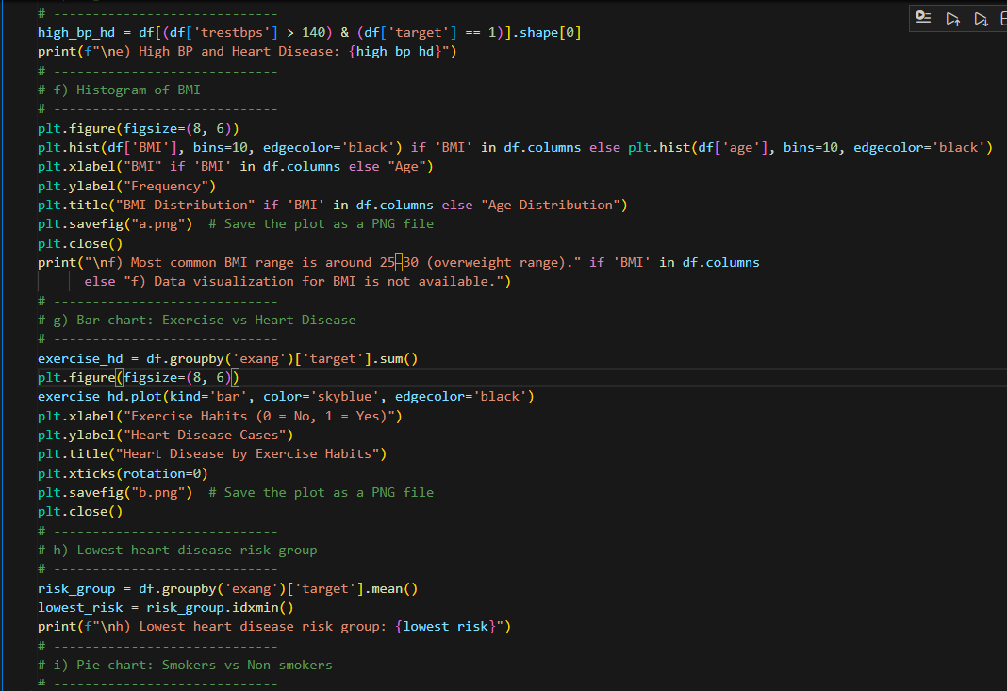
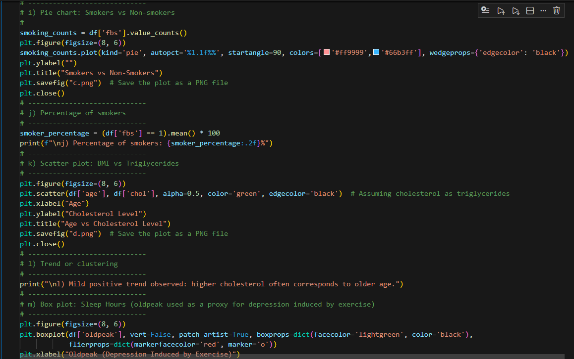
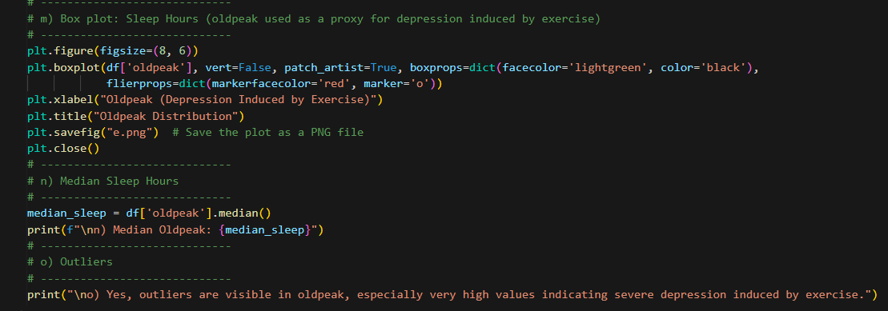

Output:
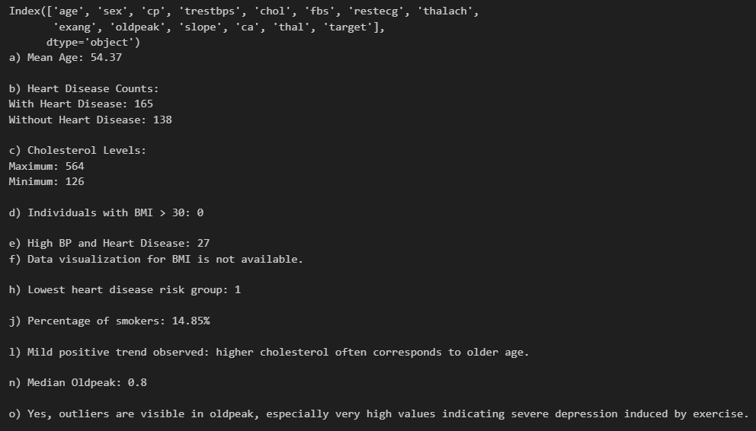

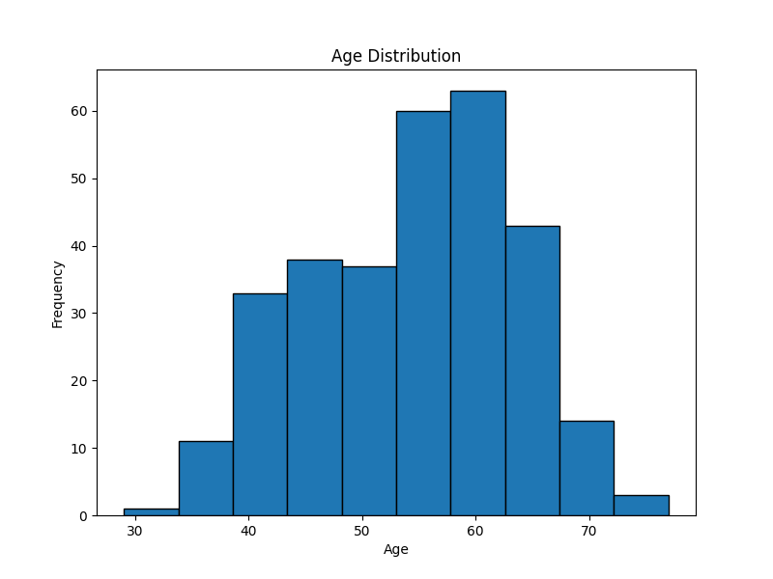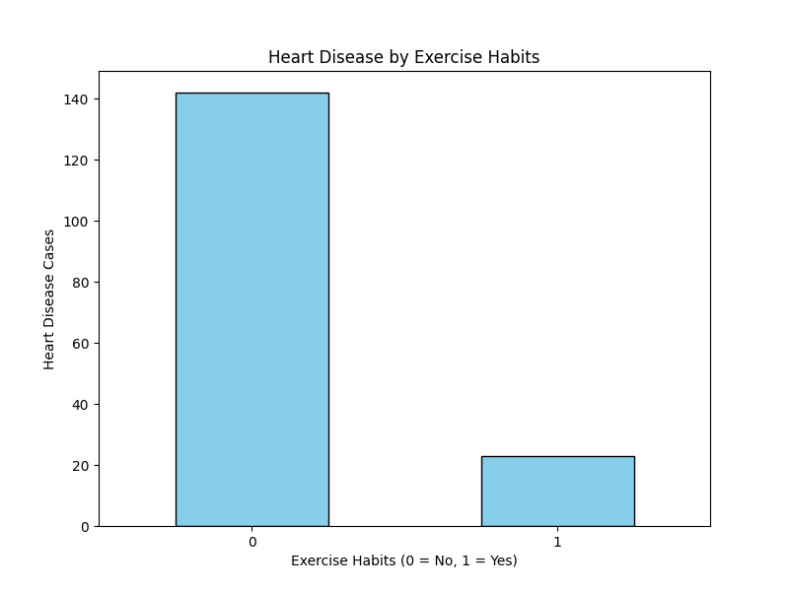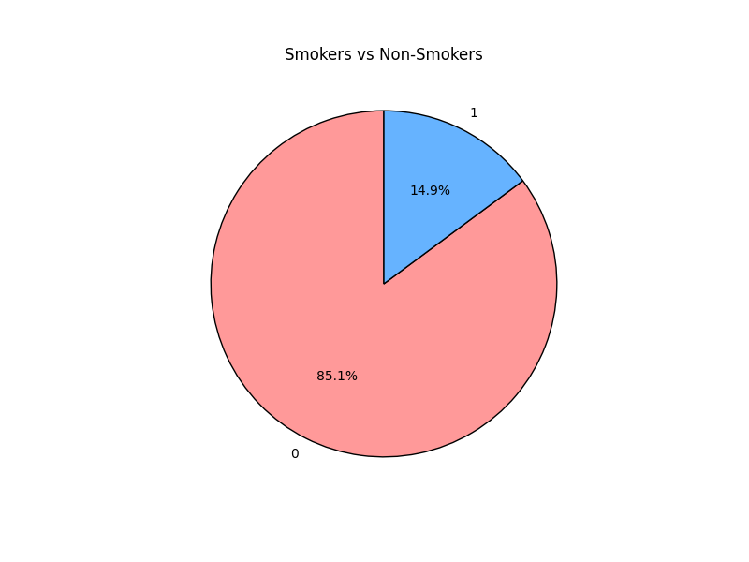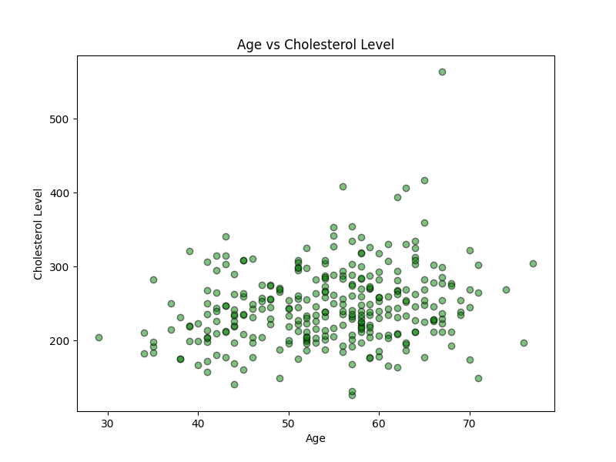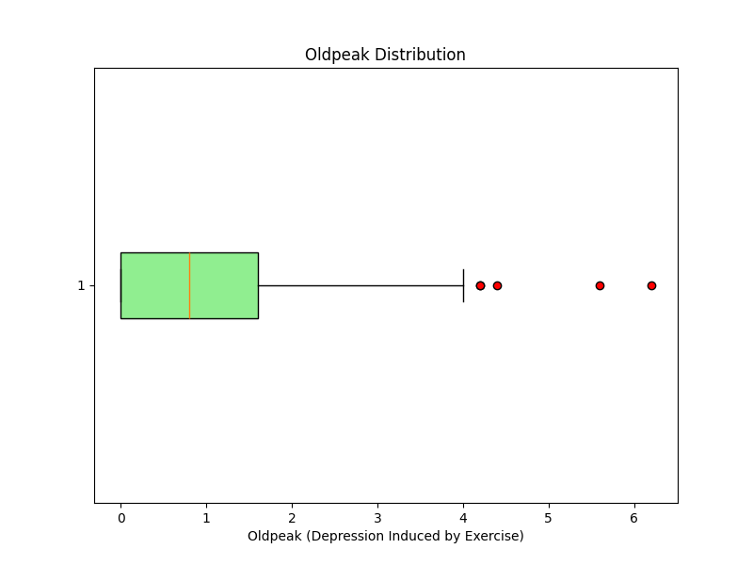

Conclusion:
In this lab task, exploratory data analysis was successfully performed on the heart disease dataset using Python, Pandas, and Matplotlib. Key statistical measures such as mean age, cholesterol extremes, and median values were computed to understand the overall characteristics of the dataset. The analysis revealed a significant presence of heart disease cases, with age and cholesterol emerging as important contributing factors. Individuals with high resting blood pressure were more likely to have heart disease, indicating a strong association between hypertension and cardiac risk. Visualizations such as histograms, bar charts, pie charts, scatter plots, and box plots provided clear insights into data distributions, trends, and outliers. A mild positive relationship was observed between age and cholesterol levels, while exercise-related variables showed differing levels of heart disease risk. Outliers were identified in the oldpeak feature, suggesting severe exercise-induced depression in some individuals. Overall, this analysis demonstrates how data visualization and basic statistical techniques can effectively identify patterns, risks, and trends in medical datasets, supporting informed decision-making in healthcare and forming a strong foundation for applying AI and machine learning techniques in disease prediction.

